3GPP TSG-RAN WG1 Meeting #125 R1-2604816
Dalian, China, May 18 – 22, 2026

Agenda Item: 10.8.1
Source: Ericsson
Title: Discussion on Evaluations for 6G Sensing
Document for: Discussion, Decision

Introduction
Integrated Sensing and Communication (ISAC) is identified as a key capability for 6G radio (6GR), enabling the RAN to support both communication and sensing functionalities within a unified infrastructure. The 6G SID states the following regarding sensing where RAN1 related studies pertaining to this agenda item is highlighted in yellow.
- Sensing – Studies to be based on use cases and associated requirements, as defined in [TR38.914]
- PHY functions and procedures for sensing technology (e.g., waveform. reference signals, measurement feedback, etc…) [RAN1, RAN4]
- Evaluate sensing performance and if necessary, extend channel modelling, for the selected use cases [RAN1]
- Aspects of integration with communication services [RAN1]
- higher layer procedures and protocol aspects [RAN2]
- RAN4 aspects of sensing including RF, coexistence, and testability in coordination with other WGs [RAN4]
Note: RAN1 identify detailed requirements, if triggered by TSG RAN

This contribution outlines the key aspects to be studied for 6G sensing: Section 2 addresses relevant use cases, Section 3 describes applicable sensing modes, Section 4 discusses the evaluation methodology, Section 5 discusses deployment scenarios for evaluation, Section 6 defines performance objectives for the identified use cases, Section 7 summarizes the required channel model extensions, and Section 8 covers the role of AI in sensing.
Table of Contents
1 Introduction 1
2 Use Cases 2
3 Sensing Modes 3
4 Evaluation Methodology 5
4.1 System-level simulations 5
4.1.1 Vehicle traffic scenario 5
4.1.2 Communication-assistance scenario 9
4.1.3 Other evaluation assumptions 13
5 Deployment Scenarios for Evaluation 14
6 Performance Objectives 14
7 Channel Model extensions to TR 38.901 16
8 AI/ML use cases for Sensing 16
9 Conclusion 17
10 References 18

Use Cases
6G Sensing is expected to support higher‑accuracy sensing requirements and a broader set of use cases, as described in TR 22.870 Section 7[1]. There are roughly 26 sensing-related use cases with 46 potential requirements described in the TR.
- TR 22.870 has roughly 26 sensing-related use cases with 46 potential requirements.
Furthermore, TR 38.914 v0.4.0[2] study on 6G scenarios and requirements made an attempt to reduce the scope of the use cases for evaluation in sensing and states that the 6GR and 6G RAN architecture shall at least support use cases of
- detection and/or tracking of passive objects, at least including UAVs, human, vehicles and AGVs
- communication assistance.
In our opinion, the scope in TR 38.914[2] captures two dimensions of 6G sensing:
- Object-centric sensing, where the networks detects and tracks moving or static passive objects that are not connected to the communication network.
- Environment-centric sensing, where the same observations are used to assist communication through awareness of obstacles, blockage, and layout.
RAN1 cannot study and evaluate all object classes and use cases with only limited number of meetings left in the 6G SI (6 meetings). A minimal set of representative use cases is required. Therefore, in our opinion, any meaningful 6G Sensing study must be able to demonstrate that it can:
- Detect and track moving objects (e.g., UAVs, pedestrians, vehicles, AGVs), and
- Detect and characterize obstacles or blockage that can assist in communication (e.g., roads, obstacles, barriers, parked vehicles), to improve communication reliability, coverage, and/or scheduling.
Detection and tracking of moving objects represent the dynamic aspect of sensing. This includes UAVs, vehicles, pedestrians, and AGVs. These use cases require estimation of position, velocity, and motion over time.
Detection of blockers or obstacles represent the structural aspect of sensing. This includes buildings, roads, barriers, infrastructure, and other stationary obstacles. These strongly affect radio propagation and determine long‑term line‑of‑sight (LoS) and reflection conditions. Knowledge of obstacles therefore enables environmental awareness that could be used to assist in communication planning and reliability.
- RAN1 study should consider at least one representative moving-object sensing scenario and one representative static-object sensing scenario, for a minimal but complete ISAC evaluation in 6G.

In RAN1 124b[6] , the following was agreed as a working assumption.
Working Assumption
For Rel-20 6G ISAC performance evaluation,
- evaluate object detection and/or tracking for the following sensing targets/objects: UAV, human, vehicle, AGV
- discuss further on evaluation on communication assistance

Based on the discussions above, and in particular Observation 2, it is proposed to make the above Working Assumption to an Agreement in RAN1. The key change would be to clarify that the communication assistance evaluation is done by sensing static objects or in other words- evaluation of stationary object detection for communication assistance.
- Make the following Working Assumption an Agreement with the changes as shown below.
  - For Rel-20 6G ISAC performance evaluation,
    - evaluate object detection and/or tracking for the following sensing targets/objects: UAV, human, vehicle, AGV
    - discuss further on evaluation of stationary object detection on for communication assistance.

Sensing Modes
6GR study considers multiple sensing modes, including but not limited to monostatic TRP, bistatic TRP‑TRP, bistatic TRP‑UE/UE‑TRP, UE-UE bistatic and UE monostatic configurations.
The use cases in TR 22.870 Section 7 that align with and support the sensing-related use cases identified in TR 38.914 are summarized in the table below, together with the sensing modes that may be applied to each.
Table 1: Mapping of 6G sensing use cases in TR 22.870 and sensing modes
Use Case ID | Use Case Title | Passive Object(s)/ | TRP Mono | TRP-TRP Bistatic | Multistatic (>=3 TRPs) | TRP–UE Bistatic | UE–UE Bistatic | UE Mono
7.3 | Safety Assistance for vulnerable pedestrians | Humans | ✔ | ✔ | ✔ | ✔ | (✔)
7.4 | High topology mapping | Environment / terrain | ✔ | ✔ | ✔ | ✔
7.5 | Low-altitude UAV supervision: UAV intrusion detection | UAVs | ✔ | ✔ | ✔ | ✔ | (✔)
7.6 | Environment object reconstruction (Building / Vehicle) | Buildings, vehicles | ✔ | ✔ | ✔ | ✔
7.7 | Road digitalisation | Roads, vehicles, pedestrians | ✔ | ✔ | ✔ | ✔
7.9 | Ship detection and tracking | Ships | ✔ | ✔ | ✔ | (✔)
7.14 | Collaborative Robots | Robots, AGVs, humans | ✔ | ✔ | (✔) | ✔ | ✔ | ✔
7.15 | Infrastructure collapse monitoring | Buildings  /Environment | ✔ | ✔ | ✔
7.16 | UAV takeoff and landing | UAVs | ✔ | ✔ | ✔ | ✔ | (✔)
7.18 | Safe and economic UAV transport | UAVs | ✔ | ✔ | ✔ | ✔
7.23 | UAV detection, classification and counting | UAVs | ✔ | ✔ | ✔ | ✔ | (✔)
7.27 | Sensing of Surroundings (Factory indoor) | Humans, AGVs, obstacles | ✔ | ✔ | ✔ | ✔ | ✔ | ✔
7.27 | Detection of Pathways, Openings | Obstacles, openings | ✔ | ✔ | ✔ | ✔ | ✔ | ✔
✔ = primary/clearly applicable mode
( ) = feasible but not typically primary mode
blank = generally not applicable
An observation from Table 1 is that TRP-only modes (monostatic, TRP–TRP bistatic, multistatic) appear broadly applicable across most use cases. However, TRP monostatic sensing has already been studied in 5G-Advanced, and we think that TRP-TRP bistatic sensing provides similar or better sensing geometry while avoiding self-interference with additional challenges such as synchronization. In addition, TRP-TRP bistatic sensing does not introduce fundamentally new RAN1 evaluation requirements compared to monostatic sensing, as the underlying sensing principles and signalling assumptions remain similar. While the propagation characteristics differ, we think that these differences do not require a separate baseline evaluation.
On the other hand, TRP‑UE sensing introduces new characteristics that were not covered in 5G‑Advanced. It improves spatial diversity and leverages the presence of UEs in dense environments. TRP‑UE sensing also better reflects realistic deployment conditions where TRPs alone do not have full visibility of the environment improving the LoS probability of the terrestrial objects. For these reasons, TRP‑UE and UE-TRP sensing modes should be considered as the baseline sensing mode for 6G RAN1 evaluation.
- RAN1 to finalize evaluation parameters and assumptions for UE-assisted NW-controlled sensing modes (TRP-UE and UE-TRP) first before considering other sensing modes.

Evaluation Methodology
This section outlines the evaluation methodology for 6G Sensing study, especially for the selected/proposed sensing use cases, sensing modes and deployment scenarios.

System-level simulations
For 6G ISAC, system-level simulations are essential to evaluate end-to-end sensing performance. In our evaluation methodology, we focus on two prioritized use cases: a vehicle traffic sensing scenario and a communication-assistance scenario. In both scenarios, TRP-UE bistatic sensing is the baseline mode, meaning a network TRP transmits sensing reference signals and one or more UEs (not regular communications users) act as receivers of the echoes of these sensing reference signals. The network deploys a set of dedicated sensing UEs (which can be thought of as static CPE UEs similar to road-side units or fixed sensors). Vehicles and buildings are treated as passive targets which means they do not generate or receive communications signals.

Vehicle traffic scenario
This scenario focuses on detection and tracking of moving vehicles in a dense urban layout. For the vehicle traffic scenario, we adopt the Urban Grid deployment scenario described in TR 38.914 and use the automotive sensing scenario use case from the TR 38.901 (Table 7.9.1-2) for sensing related aspects to generate the vehicle traffic scenario. Vehicle traffic scenario essentially then is an Urban Macro deployment with a single-layer hexagonal cell layout with no explicitly modelled buildings, and an open grid of streets. Vehicles are the only sensing targets, distributed on the roads according to the urban grid model (e.g., following the spatial distribution guidelines from TR 38.914). The sensing UEs are placed at strategic locations such as road intersections, typically at a height of around 5 m. Their placement can be randomized subject to a minimum inter-distance constraint to avoid clustering. The sensing UEs are time-synchronized with the TRPs and have known static positions, facilitating TDOA/FDOA-based localization of targets. They do not generate any uplink traffic, and their role is solely to receive echoes and send measurements to the network.
Table 2: System-Level Simulation Assumptions for Vehicle Traffic Scenario based on Urban Grid
 | Vehicle traffic scenario
Carrier Frequency | Around 4 GHz / Around 7 GHz
Aggregated System bandwidth | 4 GHz: up to 300 MHz; 7 GHz: up to 400 MHz (DL+UL)
Layout | Single layer: Hex. grid; Macro-only with Urban Grid road configuration
ISD | ISD : 250 m
BS height | Macro BS antenna height 25 m
Building size / blocks | 413 m × 230 m × 20 m
BS antenna elements | 4 GHz: up to 576; 7 GHz: up to 2304 Tx/Rx elements as agreed in 6GR evaluations.
Sensing UEs | Static, operator-deployed UEs at height ~5 m. Sensing UE locations are known to the network. They are used only for sensing (they are not regular communications users).
Sensing UE antenna configuration | Reuse the CPE UE models agreed in 6GR evaluation. A panel can be 4T16R or 8T16R for 4 GHz/7GHz with the following configuration.  16R: (M, N, P, Mg, Ng; Mp, Np)= (2, 4, 2, 1, 1; 2,4) , (dH,dV)= (0.5, 0.5)λ  CPE UEs may be equipped with multiple panels (upto 4 panels in N-E-W-S directions)  Company to report the antenna placement, directional pattern orientation of the CPE panel.
Sensing UE deployment | Sensing UEs are static, placed either  Alt 1. : at intersections or  Alt 2. : randomly/uniformly dropped with a minimum distance constraint;
Sensing Target type | Vehicles are passive sensing targets. Vehicles do not carry UEs. Pedestrians are not considered as targets in this evaluation.
Target RCS modelling | Vehicles are modelled as Targets as defined in 38.901.  Alt 1: RCS for vehicle with single scattering point  Alt 2: RCS for vehicle with multiple scattering points
Sensing mode | TRP-UE and UE-TRP bistatic modes
Channel modelling | Same as Urban Grid in TR 38.901
Physical information of sensing target/object | Size (Length x Width x Height)  Type1/2 vehicle type: 5 m x 2 m x 1.6 m
Target distribution | Urban Grid:  Option B:N targets uniformly distributed per lane on top and bottom side of the center grid following vehicle dropping option A in TR 37.885.  N = 2. (A total of 2*2*4 = 16 targets)
Mobility | Urban grid: 60 km/h in all the lane
Orientation | Lane direction in horizontal plane
Target Motion model/Trajectory | Horizontal straight-line trajectory in the East-West direction according to the lane direction, without any vehicle collision or disturbance modelled  Optional: Turning at intersections: straight 0.5 / left 0.25 / right 0.25.
Minimum 3D distance between STx/SRx and sensing target | Min distances based on min TRP/UE distances defined in TR 37.885
Minimum target-target 3D distance | Option 1: At least larger than the physical size of a sensing target  Option 2: Fixed value, 10 m.
LOS/NLOS | LOS and NLOS
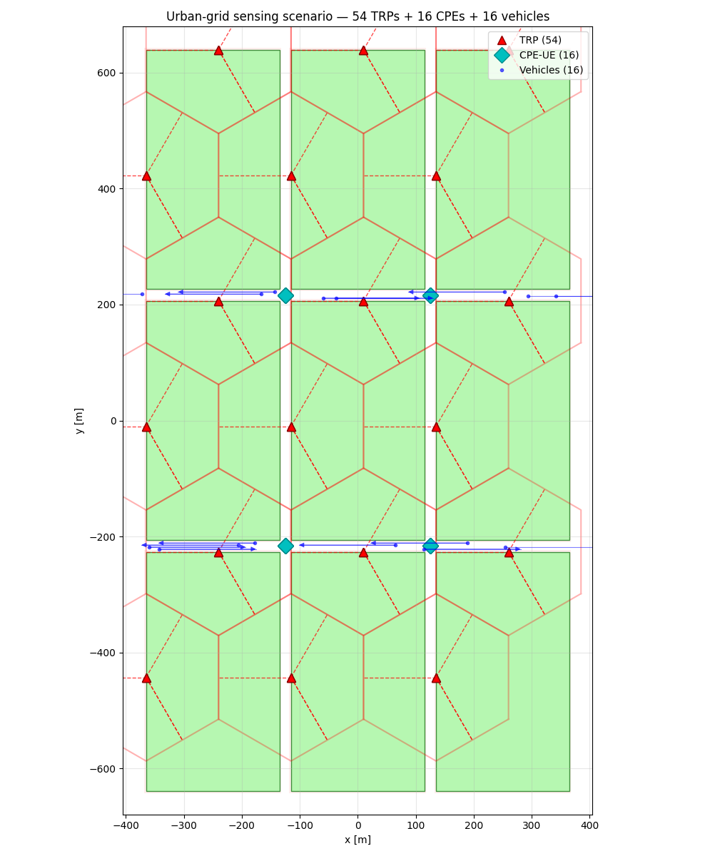
Figure 1 Urban grid vehicle scenario for 6G ISAC evaluations using TRP-UE/UE-TRP sensing mode with two vehicles per lane moving in the east -west direction with fixed CPE UEs as sensing UEs.
In Figure 1, we show a typical urban grid vehicle scenario that can be used for 6G ISAC evaluations using TRP-UE or UE-TRP bistatic sensing modes. The targets are moving vehicles shown in blue along the East-West in the lane direction. The sensing UEs are fixed, static CPE UEs shown in cyan colour, while the TRPs are shown in a hexagonal grid overlaid on top of the Urban grid shown in red.

LoS Probability Evaluation for Urban Grid
In RAN1#124b, some companies argued that at least for Urban Grid scenario, UE-TRP bistatic and TRP-UE bistatic sensing modes are not good starting points for evaluation primarily due to the low LoS probability between TRP and vehicle using the UMa channel model used for the Urban Grid scenario. Based on this, UE-UE bistatic and UE monostatic were motivated as more viable baseline candidates. While this view was motivated with single-link LoS statistics, it does not fully capture network-level sensing behaviour, particularly when multiple sensing nodes are involved.
- The argument against TRP-UE bistatic mode for Urban Grid scenario is primarily based on LoS probability of one link which does not capture the impact of multi-node spatial diversity.

In the following analysis, we consider the multi-node spatial diversity impact on the LoS probability of a vehicle in Urban Grid scenario. As mentioned in the table above, sensing UEs are static, placed either using
Alt 1.: at intersections (16 CPE UEs)
Alt 2.: uniformly dropped with a minimum distance constraint of 100m (64 CPE UEs).
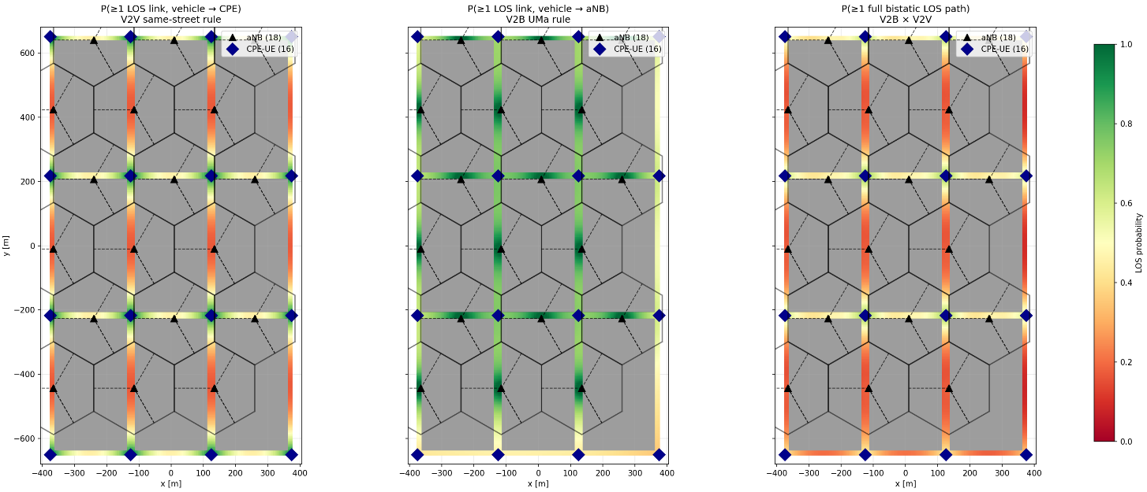
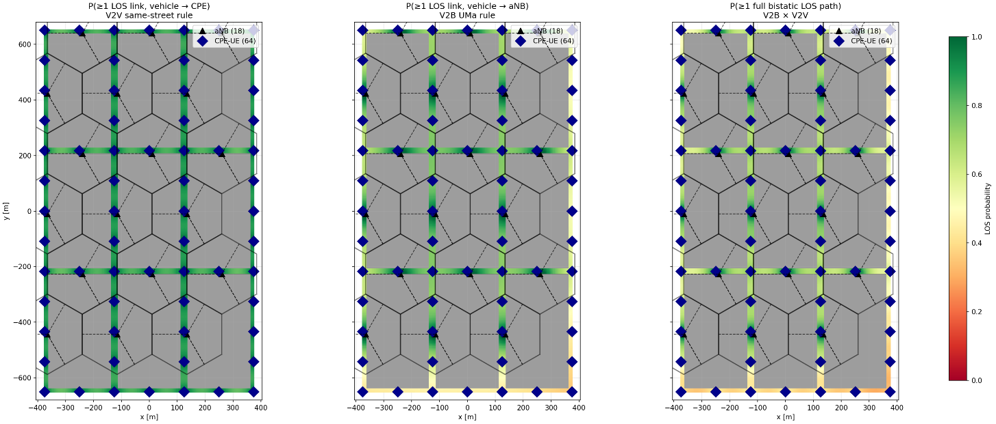
Figure 2: Heatmap of the LoS probabilities of vehicleCPE UE (left), vehicleTRP (middle) and full bistatic LoS probability (right) for sensing UE deployment at intersections (top, Alt 1 in the Table 3) and uniformly spaced (bottom, Alt 2 in the Table 3).
Let $N_{aNB}$ denote the number of the aNB sites and $N_{CPE}$ be the number of the CPE UE sites. For a vehicle at position $x$, the LOS probability to each individual site is computed as follows:
- Vehicle-to-aNB (V2B, UMa rule TR 38.901 Table 7.4.2-1), $p_{i}^{V2B}$ denotes the probability of aNB site-$i$ to position $x$ in LOS.
- Vehicle-to-CPE (V2V, same-street rule in TR 37.885), $p_{j}^{V2V}$ denotes the probability of CPE site-$j$ to position $x$ in LOS.

The aggregated probabilities: Assuming independent LOS states across sites, the probability that at least one link is LOS can be computed via the complement:
$$P_{V2B}\left(x\right)=1-\prod_{i=1}^{N_{aNB}}{(1-p_{i}^{V2B})}$$
$$P_{V2V}\left(x\right)=1-\prod_{j=1}^{N_{CPE}}{(1-p_{j}^{V2V})}$$
The probability of at least one full bistatic LOS path (requiring both a vehicle-to-aNB and a vehicle-to-CPE link in LOS simultaneously) is the product as shown below:
$$P_{bistatic}\left(x\right)=P_{V2B}\left(x\right)⋅P_{V2V}(x)$$
As shown in the Figure 2, the top figure corresponds to a deployment with a total of 16 CPE UEs located at intersections. In this case, the individual LoS probabilities for vehicle-CPE and vehicle-TRP links exhibit moderate sensing coverage. However, when considering the combined bistatic LoS condition (TRP–vehicle–CPE UE), the overall probability of establishing a valid sensing path remains reasonably strong.
There are some regions between the CPE UEs, especially in the North-South direction where they exhibit reduced combined LoS probability due to the compounded requirement of simultaneous LoS over both the links. However, assuming a denser deployment of CPE UEs (bottom figure) uniformly distributed at 100m spacing significantly improves the spatial sensing coverage.
- Increasing CPE UE density substantially enhances the probability of having at least one valid bistatic LoS geometry for ground targets across the urban grid scenario.
- The feasibility of TRP-UE bistatic sensing is strongly dependent on deployment density rather than being fundamentally limited by the LoS characteristics of individual links.
Therefore, we propose the following.
- TRP-UE bistatic and UE-TRP bistatic sensing modes are agreed as baseline sensing modes for evaluation of Urban Grid scenario for the vehicle target use case.

Communication-assistance scenario
In RAN1 #124b the following was agreed regarding the communication assistance use case and we address these points in the sub-sections below.
Agreement:
Companies are encouraged to bring input to the evaluation on communication assistance in next meeting, including but not limited to:
- Necessity of evaluation on communication assistance
- For proponents, provide: what to sense and, if necessary, what/how to assist communication
  - What metric of sensing is to be defined
  - Whether/what metric related to communication is to be defined
  - Whether performance target/KPI is to be defined, for either sensing metric or communication metric
  - Necessary channel model extension
  - Necessary update of evaluation methodology on top of 5G NR sensing evaluation methodology

Necessity of Evaluation on Communication Assistance
Communication assistance is a key motivation for ISAC in Rel-20. While many use cases focus on dynamic object detection, communication assistance can be viewed as a static object sensing (e.g., walls and fixed reflectors) which is equally fundamental, as it directly relates to environment awareness relevant for communication optimization.
Studying communication assistance as a static object detection use case allows RAN1 to:
- Evaluate the feasibility and accuracy of extracting environment information relevant for communication,
- Avoid premature assumptions on how sensed information is exploited by the aNB,
- Maintain alignment with existing NR principles, where reporting of information (e.g., CSI) is standardized, while its usage is implementation-specific.
This makes the evaluation necessary to establish whether ISAC sensing can reliably provide information that is useful for communication, without expanding scope into scheduler or beam management design.

What to Sense and How Communication Is Assisted
In this evaluation, the sensing target can be a vehicle which may or may not be included in the evaluations, but the focus of the study is to detect static objects, specifically walls in an urban grid environment. The sensing task is to estimate the approximate location of static reflectors, which characterize the radio propagation environment.
We think that RAN1 should not study how the communication system uses this information. This is similar to CSI:
- The sensing outcome is assumed to be available at the aNB,
- The interpretation and exploitation of this information for communication purposes are left to implementation,
- No explicit signaling or protocol behaviour for communication assistance is defined.
This separation ensures that RAN1 focuses strictly on measurability and accuracy, rather than functional usage.
- RAN1 evaluation focuses solely on the measurability and accuracy of sensing outputs, while the usage of this information for communication purposes should be left to implementation, analogous to CSI reporting.

Sensing Metric for Communication-assistance
The sensing metric used in this study can be estimation accuracy of static object location. There are several options discussed in the last meeting.
- Alt 1: Position error of detected wall surfaces,
- Alt 2: Range/distance or angular estimation error of dominant reflectors.
- Alt 3: Specular reflection points estimation accuracy
We think Alt 3 is a good compromise between study depth and simulator implementation effort for this use case.
This scenario focuses on exploiting reflections and blockage effects from the surrounding environment to support communication-assistance use cases by sensing obstacles or blockers in the environment (e.g., mapping obstacles or infrastructure for improved blockage prediction and network optimization). We use the same Urban Grid layout and macro-cell configuration. We characterise some obstacles in the simulation that can be detected by the sensing algorithm. These obstacles may also be considered as sensing targets, in some cases such as parked vehicles etc., however, for other obstacles, the implications on the target channel model require further consideration.

- RAN1 to evaluate communication assistance use case by studying stationary-object sensing (e.g. walls) in an urban-grid scenario, using estimation accuracy of static reflector locations as the sensing metric. No communication KPI nor channel-model extension is required. The usage of the information of communication assistance is not considered for study.

Figure 3 below shows the evaluation scenario of stationary object detection (walls) using the Urban Grid deployment.

Figure 3 Urban grid scenario for Communication-assistance use case with Type-2 EOs (walls in red) modelled for the centre building with optional targets.

Table 3: System-Level Simulation Assumptions for Communication-assistance Scenario based on Urban Grid
 | Communication-assistance scenario
Carrier Frequency | Around 4 GHz / Around 7 GHz
Aggregated System bandwidth | 4 GHz: up to 300 MHz; 7 GHz: up to 400 MHz (DL+UL)
Layout | Single layer: Hex. grid; Macro-only with Urban Grid road configuration
ISD | ISD 1: 500 m; ISD 2: 250 m
BS height | Macro BS antenna height 25 m
Building size / blocks | 413 m × 230 m × 20 m
BS antenna elements | 4 GHz: up to 576; 7 GHz: up to 2304 Tx/Rx elements
Sensing UEs | Option 1: Static, operator-deployed UEs at height ~5 m. Sensing UE locations are known to the network. They are used only for sensing (they are not regular communications users).  Option 2: regular UE dropping in Urban Grid, static at a given snapshot, and the location known at aNB
Sensing UE antenna configuration | For Option 1: Reuse the CPE UE models agreed in 6GR evaluation. A panel can be 4T16R or 8T16R for 4 GHz/7GHz with the following configuration.  16R: (M, N, P, Mg, Ng; Mp, Np)= (2, 4, 2, 1, 1; 2,4) , (dH,dV)= (0.5, 0.5)λ  CPE UEs may be equipped with multiple panels (upto 4 panels in N-E-W-S directions)  Company to report the antenna placement, directional pattern orientation of the CPE panel.  For Option 2: Reuse 6GR evaluation UE model
Sensing UE deployment | Sensing UEs are static, placed either  Alt 1. : at intersections or  Alt 2.: randomly/uniformly dropped with a minimum distance constraint;
Sensing Target type | Option1: Vehicles are targets  Option 2: No targets
Target motion model | FFS: on any target motion model.
Object modelling | Option 1: type-2 EO  Option 2: Structures/parked vehicles/  Option 3: road blockers(moving vehicles)
Sensing mode | TRP-UE and UE-TRP bistatic modes
Channel modelling | Same as Urban Grid in TR 38.901

- RAN1 agrees to consider the system-level simulation assumptions defined in Table 3 (Urban Grid for vehicle traffic scenario) and Table 4 (Urban Grid with Type-2 EOs or moving vehicles for communication-assistance scenario) as the baseline evaluation assumptions.
Finally, we emphasize that we do not mix full-blown communication traffic into these sensing simulations. In other words, we run the sensing evaluation with dedicated sensing reference signals, and the results reflect pure sensing capabilities and performance. The impact of sensing resource usage on communication can be calculated separately as was done in 5G-Advanced rather than integrating full traffic models into the sensing simulations. The impact on communication KPIs (such as throughput loss from sensing overhead, or benefits from improved link adaptation due to sensing) need not be assessed in this evaluation. This separation reduces complexity and aligns with RAN1’s focus on evaluating new functionalities for sensing. Given the limited time in the study, this decoupling is a pragmatic approach to obtain clear insights into sensing capabilities without the need for a fully integrated simulation.
- RAN1 agrees that communication and sensing are not simulated simultaneously for 6G ISAC evaluations.

Other evaluation assumptions

Doppler of Mobile Scatterers
Adding Doppler of mobile scatterers to the background channel mathematically replicates the dynamic, moving elements present in real-world environments, such as pedestrians, vehicles, or moving aspects like machinery, leaves etc. This is because, regardless of the sensing use case, the surrounding environment is rarely completely still.
In the 3GPP channel model, this reality is simulated by assigning a random Doppler frequency shift, ranging from $-v_{scatt}$ to $v_{scatt}$, and $v_{scatt}$ represents the maximum speed of the clutter to a specific proportion of the background multipath rays. This proportion is controlled by a parameter $p$ which determines the fraction of mobile scatterers and can thus be selected to appropriately model statistically larger number of mobile scatterers (higher $p$) or statistically smaller number of mobile scatterers (lower $p$).
This table illustrates the impact of background mobile scatterers on the 5G-A ISAC performance on UAV detection using TRP monostatic sensing. The first row “No mobile scatterers” correspond to our results that were submitted for 5G-A ISAC simulations[3] but with velocity ambiguity resolved here. The background channel is modelled with different fractions of mobile scatterers and maximum scatterer velocities, capturing increasing levels of environmental dynamics.
Table 4: Impact of Mobile Scatterer Velocity and Fraction on 5G-A ISAC Sensing Performance using TRP Monostatic Sensing
Maximum velocity / Fraction of mobile scatterers | Probability of detection | Probability of false alarm (type 2) | 90%ile Position accuracy [m]
No mobile scatterers | 96.00% | 1.38% | 1.045
1.5m/s, 5% | 67.55% | 0.29% | 0.974
1.5m/s, 10% | 57.54% | 0.96% | 1.033
1.5m/s, 20% | 45.61% | 0.56% | 0.957
15m/s, 5% | 60.83% | 0.41% | 1.175
15m/s, 10% | 33.42% | 0.00% | 0.934
15m/s, 20% | 14.73% | 0.08% | 0.992

When no mobile scatterers are present, the sensing system achieves high probability of detection with moderate false alarm probability, representing an idealized static background environment. As mobile scatterers are introduced, the probability of detection degrades progressively (red indicating that it’s below the performance objective of 95% set in the 5G-A ISAC study) with both increasing mobile scatterers fraction and increasing scatterer velocity. This reflects the increased Doppler spread and temporal variability in the background channel, which reduces target detectability.
At higher scatterer velocities or large fractions of mobile scatterers, detection performance degrades significantly, while the probability of false alarm remains low. This indicates that performance loss is primarily due to missed detections rather than increased false alarms. The 90-percentile position accuracy remains relatively stable across configurations, suggesting that once a target is detected, localization accuracy is less sensitive to background mobility than detection probability.
Overall, the results highlight that background Doppler from mobile scatterers is a critical factor for sensing evaluations and should be modelled, at least optionally, to capture realistic performance limits in dynamic environments.
- RAN1 agrees to model Doppler effects from mobile scatterers in the background channel, at least optionally, for the 6G sensing evaluations. The values of the relevant parameters (mobile scatterers fraction $p$ and maximum scatterer velocity $v_{scatt}$) should be selected based on the use case.

Deployment Scenarios for Evaluation
The deployment scenarios defined here provide the concrete environments in which the sensing modes identified in Section 3 and the evaluation methodology in Section 4 are applied. In RAN1 #124b[6], the following agreement was made regarding the deployment scenarios.
Agreement:
For Rel-20 6G sensing performance evaluation of object detection and/or tracking, the following cases/combinations are considered as baseline cases/combinations.
Sensing target | Indoor or outdoor | Scenario | Carrier frequency
UAV | Outdoor | UMa-AV, SMa | 4 GHz, ~7 GHz, 30 GHz (for UMa-AV only)
Human | Outdoor | UMa | 4 GHz, ~7 GHz, 30 GHz
 | Indoor | Indoor Hotspot | 4 GHz, ~7 GHz, 30 GHz
Vehicle | Outdoor | Urban Grid, Highway | 4 GHz, ~7 GHz, 30 GHz (for Urban Grid only)
AGV | Indoor | Indoor factory (SH) | 4 GHz, ~7 GHz, 30 GHz
- Note: sensing mode(s) for each row will be discussed
- Other cases/combinations can also be evaluated, reported and collected from companies.
Note: In this agreement, no intention to de-prioritize other scenarios or carrier frequencies.
Given the limited number of meetings remaining in the 6G Study Item and the need to focus evaluation efforts, we propose to restrict sensing evaluations of all these targets to a limited number of sensing modes. Section 3 identifies a broad set of sensing modes and highlights that TRP-UE and UE-TRP bistatic configurations provide key advantages for 6G sensing, including improved spatial diversity and better representation of realistic deployments where TRPs alone do not have full visibility of the environment. Furthermore, we motivated TRP-UE bistatic sensing mode for vehicle targets in Section 4. This justification can be consistently extended to other use cases too.
- Given that TRP-UE bistatic sensing is both technically justified (Section 3) and demonstrated to be feasible under realistic deployment conditions (Section 4), it forms a natural baseline for 6G ISAC evaluation.
- RAN1 agrees the following sensing modes as baseline modes for the agreed evaluation of object detection and/or tracking. Other sensing modes are not precluded.
  - UAV – TRP monostatic and TRP-TRP bistatic.
  - Human, Vehicle and AGV – TRP-UE bistatic and UE-TRP bistatic.

Performance Objectives
This section defines performance objectives for the considered sensing use cases, with the aim of supporting consistent evaluation across relevant deployment scenarios.
Performance objectives for 6G sensing evaluations should be defined using two complementary references: (i) deployment‑scenario‑specific requirements for Urban Macro/Urban Grid and Indoor Factory as specified in TR 38.914 based on the ITU requirements, and (ii) use‑case‑specific performance requirements specified in TR 22.870. Once the representative sensing use cases are selected, performance objectives may be agreed per deployment scenario by reusing or adapting the TR 38.914 requirements, while using TR 22.870 requirements as reference points for the corresponding use cases.
- Performance objectives may be defined per deployment scenario by reusing or adapting the sensing-related requirements in TR 38.914, with the use-case-specific performance requirements in TR 22.870 used as reference points, once the representative sensing use cases are selected.
Additionally, in RAN1 #124b, the following proposal was discussed regarding the velocity accuracy.
[FL4][M] Question 7.1-1
For object detection and/or tracking, update the definition of velocity accuracy for 6G ISAC evaluation:
- Velocity accuracy is defined as the absolute value of the difference between the estimated velocity and the corresponding true velocity of a sensing target. For single node TRP monostatic sensing, both the radial velocity accuracy and the 3D velocity accuracy can be estimated. The true radial velocity is the projection of true 3D velocity on the direction from TRP sensing node to target for TRP monostatic. For single pair of bi-static sensing, both the bisector velocity accuracy and the 3D velocity accuracy can be estimated. The true bisector velocity is the projection of true 3D velocity on the bisector direction of incident and scattering angle at the target.
In our opinion, there is some ambiguity in the usage of “bisector direction”. It assumes normalized bisector direction and is not aligned with the TR 38.901 formulation and can lead to inconsistent definitions across companies.
The channel model in TR 38.901, step 14 of 7.9.4.1 expresses bistatic doppler in equation 7.9.4-5 clearly as follows –
Doppler frequency $f_{D,n^{'},m^{'},n,m}^{k,p}\left(t\right)$ defined as
$f_{D,n^{'},m^{'},n,m}^{k,p}\left(t\right)=\frac{{\hat{r}}_{rx,k,p,n^{'},m^{'}}^{T}\left(t\right){\bar{v}}_{rx}\left(t\right)+{\hat{r}}_{k,p,n^{'},m^{'}}^{T}\left(t\right){\bar{v}}_{k,p}\left(t\right)}{λ_{0}}+\frac{{\hat{r}}_{tx,k,p,n,m}^{T}\left(t\right){\bar{v}}_{tx}\left(t\right)+{\hat{r}}_{k,p,n,m}^{T}{\left(t\right)\bar{v}}_{k,p}\left(t\right)}{λ_{0}}$ (7.9.4-5)
If we assume that the sensing Tx and Rx do not move and are static, this reduces to the bistatic doppler and can be abstracted for easy understanding as follows
$$f_{d}= \frac{r_{tx}^{T}v+r_{rx}^{T}v}{λ_{0}}$$
Where $r_{tx}$: unit-norm vector (target transmitter) , $r_{rx}$: unit-norm vector (target receiver), $v$: true target 3D velocity.
Therefore, from the above equations, it can be noted that $r_{tx}^{T}v$ is the projection of the target velocity onto the unit-norm vector from the target to the transmitter and $r_{rx}^{T}v$ is the projection of the target velocity onto the unit-norm vector from the target to the receiver.
Hence, we make the following observation and proposal.

- Bistatic bisector velocity can be derived directly from the 3GPP channel model TR 38.901 (Eq. 7.9.4-5) as the sum of two projections of the target velocity vector: (i) onto the unit-norm vector from target to the transmitter and (ii) onto the unit-norm vector from target to the receiver.
- Modify the following FL Question 7.1-1 to incorporate the definition of bistatic bisector velocity into the Velocity accuracy objective.
For object detection and/or tracking, update the definition of velocity accuracy for 6G ISAC evaluation:
    - Velocity accuracy is defined as the absolute value of the difference between the estimated velocity and the corresponding true velocity of a sensing target.
      - For single node TRP monostatic sensing, both the radial velocity accuracy and the 3D velocity accuracy can be estimated. The true radial velocity is the projection of true 3D velocity on the direction from TRP sensing node to target for TRP monostatic.
      - For single pair of bi-static sensing, both the bistatic velocity accuracy and the 3D velocity accuracy can be estimated. The true bisector velocity is the projection of true 3D velocity on the bisector direction of incident and scattering angle at the target. The true bistatic velocity is defined as the sum of two projections of the true 3D velocity vector: (i) the projection onto the unit-norm vector from target to the transmitter, and (ii) the projection onto the unit-norm vector from target to the receiver.

Channel Model extensions to TR 38.901
As described in our earlier contribution[4] there are still some aspects of channel modelling that needs updating. For e.g., EO Type 1 unintended object modelling, micro-Doppler, complex scatterer dynamics, or mixed target types requires careful consideration for realistic channel modelling of ISAC, not only for monostatic modes but also for bistatic modes.
It is observed that although the SID mentions channel model extensions, TR 38.901 is not in the list of TRs in the “Expected Outcome” of the 6G SI. Therefore, any channel model extensions agreed will not be applied automatically to TR 38.901 but can only be used in this study. In RAN1, studies historically have allowed performance evaluations to be carried out using reasonable assumptions and slight adaptations of existing channel models, without necessarily requiring immediate updates to TR 38.901.
It is also observed that while certain sensing use cases may benefit from refinements or extensions to existing channel modelling assumptions, introducing substantive channel model updates within the current RAN1 study phase may be challenging timewise. It would require significant effort, coordination among different companies and broad consensus on the scope of the channel modelling updates in RAN1, which may be challenging within the available study timeline (only 6 meetings). Focusing the limited RAN1 study time on evaluating sensing use cases and extracting insights, rather than on detailed channel model modifications, may therefore be more effective at this stage.
Given these considerations, it is noted that any potential channel model enhancements for sensing could be more efficiently discussed and aligned offline among interested parties, where sufficient consensus is reached, be brought to RAN1 at a later stage for consideration.
- Companies are encouraged to align offline on channel model extensions and when a sufficiently stable proposal with broad support is reached, can be brought to RAN1 for agreement and potential inclusion in TR 38.901.

AI/ML use cases for Sensing
During Rel-20 AI/ML discussion on potential use cases for AIML, the case of digital twin construction using AI/ML sensing was discussed with network sided model or distributed model. The model input for NW sided model was described as UE sensing measurement reports and network side monostatic sensing measurements. The analysis also mentions further UE reporting enhancements for 2-sided model support[5].
From our perspective, it is too early to consider AI/ML aspects to sensing, since first a sensing framework should be available. If model input and output are matched to sensing measurements and sensing results provided by RAN, the main additional impact of AI/ML based sensing is toward LCM framework, similar to how AI/ML-positioning was built on top of pre-Rel19 positioning framework.
- AI/ML use cases for sensing should be downprioritized until a sensing architecture and framework are established.

Conclusion
In the previous sections we made the following observations:
Observation 1 TR 22.870 has roughly 26 sensing-related use cases with 46 potential requirements.
Observation 2 RAN1 study should consider at least one representative moving-object sensing scenario and one representative static-object sensing scenario, for a minimal but complete ISAC evaluation in 6G.
Observation 3 The argument against TRP-UE bistatic mode for Urban Grid scenario is primarily based on LoS probability of one link which does not capture the impact of multi-node spatial diversity.
Observation 4 Increasing CPE UE density substantially enhances the probability of having at least one valid bistatic LoS geometry for ground targets across the urban grid scenario.
Observation 5 The feasibility of TRP-UE bistatic sensing is strongly dependent on deployment density rather than being fundamentally limited by the LoS characteristics of individual links.
Observation 6 RAN1 evaluation focuses solely on the measurability and accuracy of sensing outputs, while the usage of this information for communication purposes should be left to implementation, analogous to CSI reporting.
Observation 7 Given that TRP-UE bistatic sensing is both technically justified (Section 3) and demonstrated to be feasible under realistic deployment conditions (Section 4), it forms a natural baseline for 6G ISAC evaluation.
Observation 8 Bistatic bisector velocity can be derived directly from the 3GPP channel model TR 38.901 (Eq. 7.9.4-5) as the sum of two projections of the target velocity vector: (i) onto the unit-norm vector from target to the transmitter and (ii) onto the unit-norm vector from target to the receiver.

Based on the discussion in the previous sections we propose the following:
Proposal 1 Make the following Working Assumption an Agreement with the changes as shown below.
a. For Rel-20 6G ISAC performance evaluation,
i. evaluate object detection and/or tracking for the following sensing targets/objects: UAV, human, vehicle, AGV
ii. discuss further on evaluation of stationary object detection on for communication assistance.
Proposal 2 RAN1 to finalize evaluation parameters and assumptions for UE-assisted NW-controlled sensing modes (TRP-UE and UE-TRP) first before considering other sensing modes.
Proposal 3 TRP-UE bistatic and UE-TRP bistatic sensing modes are agreed as baseline sensing modes for evaluation of Urban Grid scenario for the vehicle target use case.
Proposal 4 RAN1 to evaluate communication assistance use case by studying stationary-object sensing (e.g. walls) in an urban-grid scenario, using estimation accuracy of static reflector locations as the sensing metric. No communication KPI nor channel-model extension is required. The usage of the information of communication assistance is not considered for study.
Proposal 5 RAN1 agrees to consider the system-level simulation assumptions defined in Table 3 (Urban Grid for vehicle traffic scenario) and Table 4 (Urban Grid with Type-2 EOs or moving vehicles for communication-assistance scenario) as the baseline evaluation assumptions.
Proposal 6 RAN1 agrees that communication and sensing are not simulated simultaneously for 6G ISAC evaluations.
Proposal 7 RAN1 agrees to model Doppler effects from mobile scatterers in the background channel, at least optionally, for the 6G sensing evaluations. The values of the relevant parameters (mobile scatterers fraction $p$ and maximum scatterer velocity $vscatt$) should be selected based on the use case.
Proposal 8 RAN1 agrees the following sensing modes as baseline modes for the agreed evaluation of object detection and/or tracking. Other sensing modes are not precluded.
a. UAV – TRP monostatic and TRP-TRP bistatic.
b. Human, Vehicle and AGV – TRP-UE bistatic and UE-TRP bistatic.
Proposal 9 Performance objectives may be defined per deployment scenario by reusing or adapting the sensing-related requirements in TR 38.914, with the use-case-specific performance requirements in TR 22.870 used as reference points, once the representative sensing use cases are selected.
Proposal 10 Modify the following FL Question 7.1-1 to incorporate the definition of bistatic bisector velocity into the Velocity accuracy objective. For object detection and/or tracking, update the definition of velocity accuracy for 6G ISAC evaluation:
i. Velocity accuracy is defined as the absolute value of the difference between the estimated velocity and the corresponding true velocity of a sensing target.
1. For single node TRP monostatic sensing, both the radial velocity accuracy and the 3D velocity accuracy can be estimated. The true radial velocity is the projection of true 3D velocity on the direction from TRP sensing node to target for TRP monostatic.
2. For single pair of bi-static sensing, both the bistatic velocity accuracy and the 3D velocity accuracy can be estimated. The true bisector velocity is the projection of true 3D velocity on the bisector direction of incident and scattering angle at the target. The true bistatic velocity is defined as the sum of two projections of the true 3D velocity vector: (i) the projection onto the unit-norm vector from target to the transmitter, and (ii) the projection onto the unit-norm vector from target to the receiver.
Proposal 11 Companies are encouraged to align offline on channel model extensions and when a sufficiently stable proposal with broad support is reached, can be brought to RAN1 for agreement and potential inclusion in TR 38.901.
Proposal 12 AI/ML use cases for sensing should be downprioritized until a sensing architecture and framework are established.

References
- 3GPP TR 22.870: “Study on 6G Use Cases and Service Requirements”, v20.0.0 (2026-03-20).
- 3GPP TR 38.914: “Study on 6G Scenarios and requirements”, v0.4.0 (2026-03-18), RP-260073.
- R1-2601459, Discussion on ISAC for NR, Ericsson, RAN1#124, Gothenburg, 2026.
- R1-2506157, Evaluation assumptions for 6GR, Ericsson, RAN1#122, Bengaluru 2025.
- R1-2600986, Observations and agreements for AI/ML in 6GR interface, Samsung (Moderator), RAN1#124, Gothenburg, 2026.
- R1-2602522, FL summary #4 on ISAC evaluations, Moderator (CATT), RAN1 #124bis, St. Julians Malta, 2026.

